TITLE OF THE PROJECT:-

Enforce least-privilege access through identity-aware, application-specific access policies using Zscaler Private Access (ZPA).

Overview:
This project focuses on implementing a secure access model based on the principle of least privilege to protect organizational applications and data. Instead of providing users with full network access, the system grants application-specific access based on user identity, device security posture, and application risk level. By using ZPA, organizations can create secure connections between users and internal applications without exposing the internal network to the internet.
The project also includes identifying common security vulnerabilities, analyzing them using vulnerability scanning tools, and applying Zero Trust access policies to reduce security risks. Through identity-aware policies, device verification, and content-aware access control, the system ensures that only authorized users and trusted devices can access sensitive applications.
This approach helps reduce the attack surface, prevent unauthorized access, protect sensitive data, and improve overall cybersecurity posture within an organization.

S.NO | NAME | COLLEGE | CONTACT
1 | Dharani Ganesh A | SHRI NEHRU MAHA VIDYALAYA COLLEGE OF ARTS & SCIENCES | Subi9843@gmail.com
2 | MadhanRaj M | SHRI NEHRU MAHA VIDYALAYA COLLEGE OF ARTS & SCIENCES | mraj32154@gmail.com
3 | Mohammed Ashik A | SHRI NEHRU MAHA VIDYALAYA COLLEGE OF ARTS & SCIENCES | jerrykd488@gmail.com
4 | Sowndarya M | SHRI NEHRU MAHA VIDYALAYA COLLEGE OF ARTS & SCIENCES | msowndaryaa56@gmail.com

PROJECT DETAILS

TITLE:

Enforce least-privilege access through identity-aware, application-specific access policies using Zscaler Private Access (ZPA)

INTRO:

In modern organizations, securing access to internal applications and sensitive data is a major challenge due to increasing cyber threats. Traditional network security models often provide users with broad network access, which increases the risk of unauthorized access and data breaches. To overcome this problem, organizations are adopting the Zero Trust security model, where no user or device is trusted by default.

This project focuses on implementing least-privilege access control using Zscaler Private Access (ZPA). By verifying user identity, checking device posture, evaluating application risk, and applying content-aware policies, the system ensures that users can only access the specific applications required for their tasks. This approach helps protect sensitive business resources and improves overall cybersecurity.

ABSTRACT:

This project aims to enhance application security by enforcing least-privilege access policies using Zscaler Private Access (ZPA). The project begins with identifying common security vulnerabilities based on OWASP standards and analyzing them using vulnerability scanning tools. After identifying potential risks, the project implements a Zero Trust access framework that provides secure, identity-aware, and application-specific access to internal resources.
By combining identity verification, device posture checks, application risk evaluation, and content-aware access policies, the system restricts unauthorized access and reduces the attack surface. This approach helps organizations protect sensitive data, prevent cyber attacks, and ensure secure access to internal applications. The project demonstrates how modern security solutions can strengthen enterprise cybersecurity and improve access management.

Use Case Scenarios:

- Secure Remote Employee Access
Employees working remotely can securely access internal company applications through Zscaler Private Access. Access is granted only after verifying the user identity and device security status, ensuring that only authorized users can connect to specific applications.

- Third-Party Vendor Access Control
Organizations often allow vendors or partners to access certain applications. Using identity-aware policies, vendors can be given access only to the specific applications required for their work, without exposing the entire internal network.

- Protection of Sensitive Applications
Critical business applications such as databases or financial systems can be protected using application-specific access policies. Only users with proper authorization and secure devices are allowed to interact with these applications.

- Secure Access from Untrusted Networks
Employees accessing company applications from public networks (such as cafés or hotels) can still connect securely. ZPA creates a secure connection between the user and the application without exposing the internal network.

- Data Protection through Content-Aware Access
When users access sensitive information, content-aware policies can restrict actions such as downloading, copying, or sharing confidential files, helping organizations prevent data leakage and protect business information.

Stage 1
S.NO | Vulnerability name | CWE/CVE no.
1 | Improper Authorization | CWE 285
2 | Sensitive Cookie Without Secure Attribute | CWE 614
3 | Use of Unmaintained Third Party Components | CWE 1104
4 | Use of Hard-coded Cryptographic Key | CWE 321
5 | XML Injection (aka Blind XPath Injection) | CWE 91
6 | Protection Mechanism Failure | CWE 693
7 | SQL Injection | CWE 89
8 | Improper Integrity Check | CWE 353
9 | Insufficient Logging and Monitoring | CWE 778
10 | Improper Handling of Exceptional Conditions | CWE 703

REPORT:
Vulnerability name: Improper Authorization
CWE/CVE number: CWE-285
OWASP category: A01:2025 Broken Access Control
DESCRIPTION:
Improper Authorization occurs when an application does not correctly verify whether a user has permission to access a specific resource or perform an action. Attackers can exploit this weakness to access restricted data or perform unauthorized operations.
BUSINESS IMPACT:
Unauthorized users may access confidential data, modify sensitive information, or perform administrative actions. This can lead to data breaches, financial losses, and reputational damage.
REPORT:
Vulnerability name: Sensitive Cookie Without Secure Attribute
CWE/CVE number: CWE-614
OWASP category: A02:2025 Security Misconfiguration
DESCRIPTION:
This vulnerability occurs when cookies containing sensitive information such as session IDs are transmitted without the Secure attribute. Without this attribute, cookies may be sent over unencrypted HTTP connections, making them vulnerable to interception.
BUSINESS IMPACT:
Attackers can steal session cookies and hijack user sessions. This can result in unauthorized account access, data theft, and compromise of user privacy.

REPORT:
Vulnerability name: Use of Unmaintained Third-Party Components
CWE/CVE number: CWE-1104
OWASP category: A03:2025 Software Supply Chain Failures
DESCRIPTION:
Applications sometimes rely on external libraries or frameworks that are no longer maintained or updated. These components may contain known vulnerabilities that attackers can exploit.
BUSINESS IMPACT:
Attackers can exploit these vulnerabilities to compromise the application, execute malicious code, or access sensitive information.

REPORT:
Vulnerability name: Use of Hard-coded Cryptographic Key
CWE/CVE number: CWE-321
OWASP category: A04:2025 Cryptographic Failures
DESCRIPTION:
Hard-coded cryptographic keys occur when encryption keys are directly embedded in the source code. Attackers who obtain the application code can extract the key and decrypt protected information.
BUSINESS IMPACT:
Sensitive data such as passwords, personal information, or financial details may be exposed. This can lead to major security breaches and regulatory penalties.

REPORT:
Vulnerability name: SQL Injection
CWE/CVE number: CWE-89
OWASP category: A05:2025 Injection
DESCRIPTION:
SQL Injection occurs when user input is included in database queries without proper validation or parameterization. Attackers can manipulate queries to retrieve, modify, or delete database data.
BUSINESS IMPACT:
Attackers may access confidential records, alter stored data, or delete important information. This can severely impact business operations.

REPORT:
Vulnerability name: Protection Mechanism Failure
CWE/CVE number: CWE-693
OWASP category: A06:2025 Insecure Design
DESCRIPTION:
Protection mechanism failure occurs when security controls such as authentication, authorization, or validation mechanisms are poorly designed or missing. This allows attackers to bypass security measures.
BUSINESS IMPACT:
Attackers may gain unauthorized access, manipulate system functionality, or disrupt services.
REPORT:
Vulnerability name: Weak Password Requirement
CWE/CVE number: CWE-521
OWASP category: A07:2025 Identification and Authentication Failures
DESCRIPTION:
This vulnerability occurs when the system allows users to create weak or easily guessable passwords. Without strong password policies, attackers can perform brute-force or dictionary attacks.
BUSINESS IMPACT:
Unauthorized users may gain access to accounts and sensitive information, leading to data breaches and financial loss.

REPORT:
Vulnerability name: Improper Integrity Check
CWE/CVE number: CWE-353
OWASP category: A08:2025 Software and Data Integrity Failures
DESCRIPTION:
Improper integrity validation occurs when software updates or external data sources are not verified before execution. Attackers may modify files or inject malicious code.
BUSINESS IMPACT:
Compromised software may install malware, steal data, or disrupt system operations.

REPORT:
Vulnerability name: Insufficient Logging and Monitoring
CWE/CVE number: CWE-778
OWASP category: A09:2025 Security Logging and Monitoring Failures
DESCRIPTION:
This vulnerability occurs when applications fail to record or monitor important security events. Without logging and monitoring, security incidents may go unnoticed.
BUSINESS IMPACT:
Attackers may remain undetected in the system for long periods, increasing the damage caused by attacks.

REPORT:
Vulnerability name: Improper Handling of Exceptional Conditions
CWE/CVE number: CWE-703
OWASP category: A10:2025 Server-Side Request Forgery / Misconfiguration
DESCRIPTION:
Improper handling of exceptional conditions occurs when an application does not properly manage unexpected errors or exceptional situations. Attackers can exploit these weaknesses to crash systems or bypass security controls.
BUSINESS IMPACT:
This vulnerability may lead to system instability, service disruption, and potential security breaches.

SCREENSHOT:
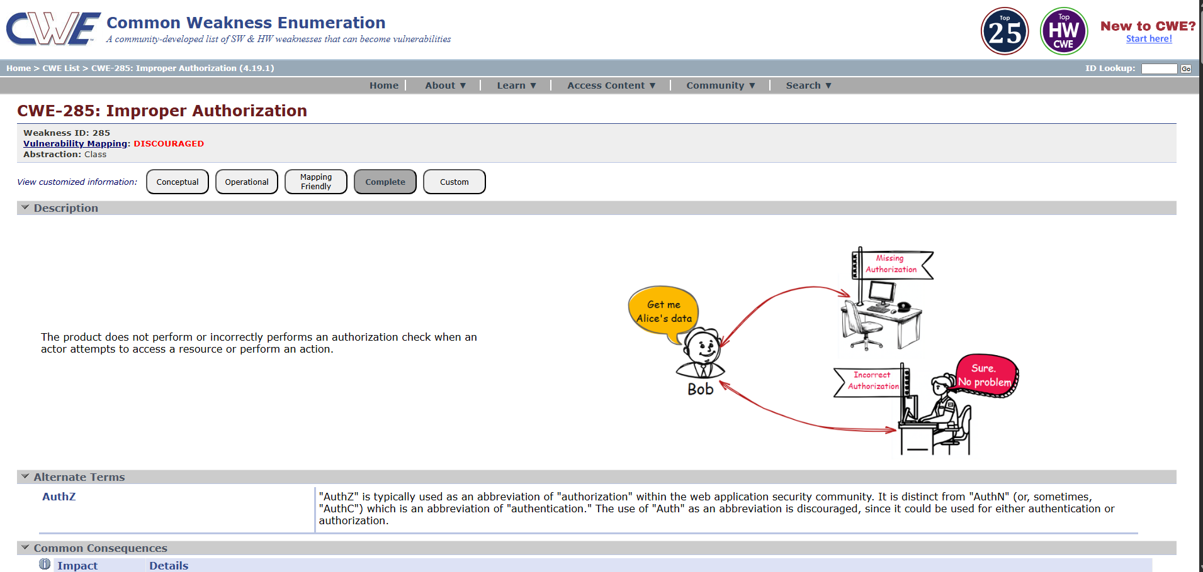
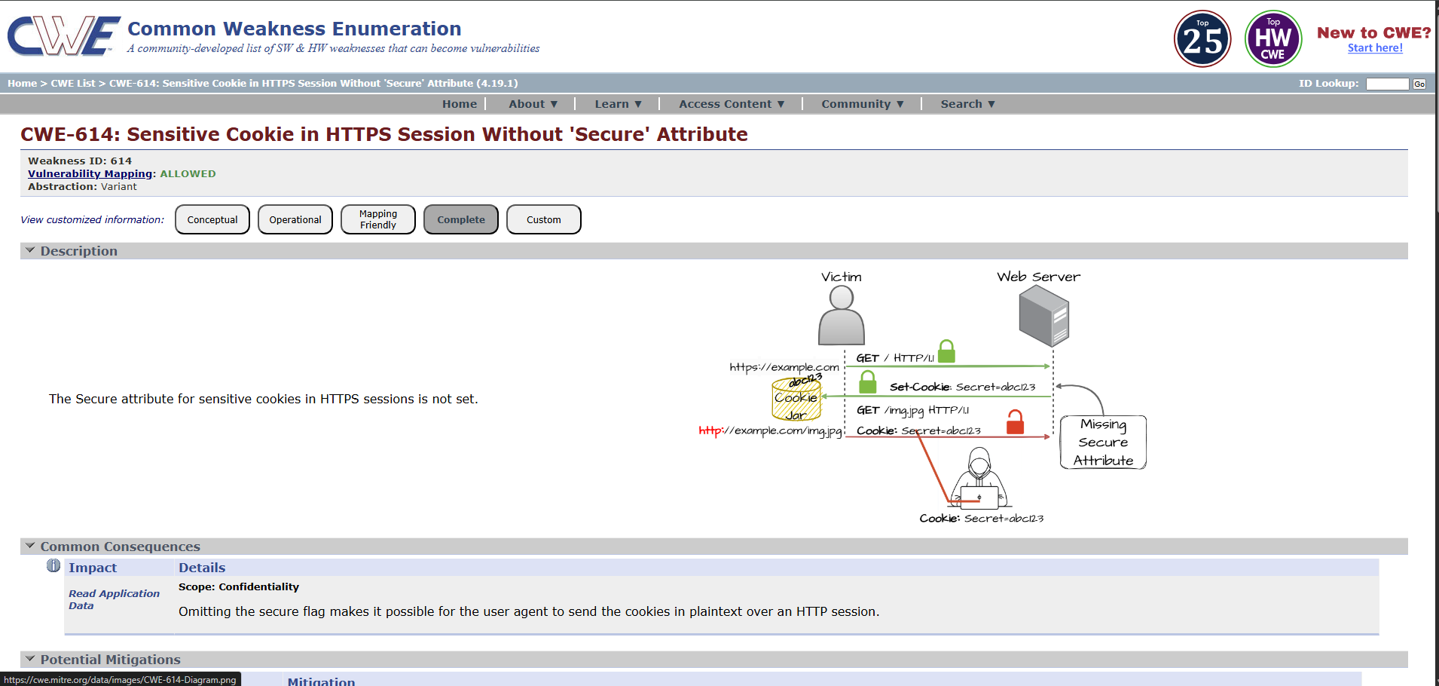

Stage 2:
TITLE: Nessus
Overview:
Nessus is a popular vulnerability scanning tool developed by Tenable. It is widely used in cybersecurity to identify security weaknesses in computers, networks, servers, and applications. Nessus helps organizations detect vulnerabilities before attackers can exploit them, making it an important tool for maintaining system security.
Nessus works by scanning target systems using thousands of plugins that check for known vulnerabilities such as missing patches, weak passwords, open ports, and misconfigured services. During the scan, it analyzes the system and compares the results with its vulnerability database to identify potential security risks. The detected vulnerabilities are then categorized based on their severity level.
After completing the scan, Nessus generates detailed reports that include information about the vulnerability, its severity, possible impact, and recommended solutions to fix the issue. These reports help security professionals understand the risks and take corrective actions. Because of its accuracy, regular updates, and easy-to-use interface, Nessus is widely used for vulnerability assessment and security auditing in many organizations.

s.no | Vulnerability name | Severity | plugins
1 | Service Detection | info | 206982
2 | Sensitive Cookie Without Secure Attribute | medium | 57582
3 | SQL Injection | High | 34396

REPORT:

Target website: https://public-firing-range.appspot.com

Target ip address: 44.228.249.3

Vulnerability name: Service Detection

Severity: info

Plugins: 206982

Description: Service Detection is a scanning technique used by vulnerability scanners to identify the services running on open ports of a system.
During a security scan, the scanner connects to different ports on the target system and analyzes responses to determine which service is running. For example, it may detect services such as:

- Web servers (HTTP / HTTPS)
- FTP servers
- SSH services
- Database services
- Email services (IMAP, SMTP)

Solution: Disable unnecessary services, close unused ports using firewall rules, restrict service access to trusted networks, and regularly monitor systems with vulnerability scanners to reduce the attack surface.

Business imapct:
Service detection reveals information about the services running on a system. Attackers can use this information to identify potential targets and attempt attacks on vulnerable services. This may increase the attack surface and could lead to unauthorized access or exploitation if services are not properly secured.

REPORT :

Target Website: http://demo.owasp-juice.shop

Target ip address: 81.169.145.156

Vulnerability name: Sensitive Cookie Without Secure Attribute
Severity: Medium
Plugins: 57582
Description: Sensitive Cookie Without Secure Attribute occurs when a web application sends cookies without enabling the Secure flag. Without this flag, cookies can be transmitted over unencrypted HTTP connections instead of only through HTTPS.
This means the cookie containing sensitive information such as session IDs or authentication tokens can be intercepted by attackers during network communication.
Solution: Configure the web application to set the Secure attribute for cookies so that they are only transmitted over HTTPS connections. Also ensure that the website uses HTTPS for all sensitive communications.
Business Impact: If cookies are transmitted without the Secure attribute, attackers may intercept session cookies and perform session hijacking. This can allow unauthorized access to user accounts and sensitive information, leading to security risks and potential data breaches.
REPORT
Target website: http://dvwa.co.uk
Target ip Address: 172.67.154.147
Vulnerability name: SQL Injection
Severity: High
Plugins: 34396
Description: SQL Injection is a web security vulnerability that allows attackers to interfere with database queries made by an application. It occurs when user input is not properly validated or sanitized before being used in SQL queries.
Attackers can insert malicious SQL commands to access, modify, or delete data stored in the database.
Solution: Use parameterized queries or prepared statements, validate user inputs, and implement proper input sanitization. Web applications should also use secure coding practices and apply regular security testing.
Business Impact: SQL Injection can allow attackers to gain unauthorized access to the database and sensitive information such as user credentials or financial data. This may lead to data theft, data modification, or complete database compromise, which can severely impact business operations and customer trust.

Stage 3:
Tittle: Enforce least-privilege access through identity-aware, application-specific access policies using Zscaler Private Access (ZPA).
Overview: This stage focuses on implementing a Zero Trust access model where users are granted access only to the applications they need based on identity, device security, and application sensitivity. Instead of giving full network access, ZPA provides secure, application-level access by verifying the user, checking device posture, evaluating application risk, and applying content-aware policies. This approach helps organizations enforce least-privilege access, reduce attack surfaces, and protect sensitive business data.
Identity : Identity-based access ensures that only authenticated and authorized users can access specific applications. Access policies are defined based on user identity, roles, and organizational groups, ensuring that users only access resources necessary for their work.
Device posture : Device posture checks the security status of the user’s device before granting access. ZPA verifies whether the device complies with security requirements such as updated operating systems, security patches, and endpoint protection. Only trusted and secure devices are allowed to access internal applications.
Application risk : Application risk evaluation helps determine the security level and sensitivity of each application. High-risk or critical applications are protected with stricter access controls, ensuring that only authorized users can interact with them.

Content aware access : Content aware access controls user access based on the type and sensitivity of the data within applications. It monitors user activities and applies security policies to prevent unauthorized downloading, sharing, or transfer of confidential information, helping to protect sensitive business data.
CONCLUSION :

Stage 1 :
Stage 1 focuses on identifying common web application vulnerabilities based on the OWASP Top 10 security risks. The analysis highlights several security weaknesses such as improper authorization, SQL injection, and insufficient logging. Understanding these vulnerabilities helps organizations recognize potential threats and improve secure coding practices. Addressing these issues is essential to protect sensitive data, maintain system integrity, and ensure secure application development.

Stage 2 :
Stage 2 demonstrates the use of the vulnerability scanning tool Nessus to detect security weaknesses in systems and applications. The scan results identified issues such as service detection, sensitive cookie misconfiguration, and SQL injection risks. By analyzing these findings and implementing recommended solutions, organizations can reduce security risks, strengthen system defenses, and improve overall network security posture.

Stage 3 :
Stage 3 focuses on implementing Zero Trust security principles using Zscaler Private Access (ZPA). By enforcing identity-based access, verifying device posture, evaluating application risk, and applying content-aware policies, organizations can ensure that users only access the resources they need. This least-privilege approach significantly reduces the attack surface, improves data protection, and enhances overall enterprise security.

FUTURE SCOPE
Stage 1 – Vulnerability Identification
In the future, vulnerability identification can be improved by integrating advanced security testing techniques such as automated vulnerability scanners, penetration testing, and secure code analysis. Organizations can also adopt continuous security monitoring to detect new vulnerabilities early and apply security patches regularly to maintain strong application security.

Stage 2 – Vulnerability Scanning
Future improvements in vulnerability scanning using tools like Nessus can include continuous automated scanning and real-time threat detection. Integrating scanning tools with security management platforms and threat intelligence systems will help organizations quickly identify and respond to emerging threats, improving overall network security.

Stage 3 – Secure Access with ZPA
In the future, secure access systems such as Zscaler Private Access can be enhanced with AI-based threat detection, stronger device posture verification, and adaptive access policies. Organizations can further strengthen the Zero Trust model by continuously analyzing user behavior and automatically adjusting access controls to protect sensitive applications and data.

Topics Explored : OWASP top 10,scanning , Vulnerability ,awareness, identity
Tools Explored: Zscaler,nessus,Owasp,hackthissite

